**PRACTICAL NO :04**

**AIM : DESIGN A WEBPAGE THAT MAKE A USE OF CASCADING STYLE SHEETS WITH :**

1. **CSS properties to change the background of a page.**
2. **CSS properties to change fonts and text styles.**
3. **. CSS properties to change the background of a page.**

**Code :**

<!DOCTYPE html>

<html>

<head>

<title> background properties with CSS </title >

<style>

body

{

background-color:lightblue ;

background-image :url("flower.jpg") ;

background-position:center;

background-attachment:fixed;

background-repeat-y:no-repeat;

}

</style>

</head>

<body>

<h1> THIS IS HEADING</h1>

<p> this is paragraph</p>

</body>

</html>

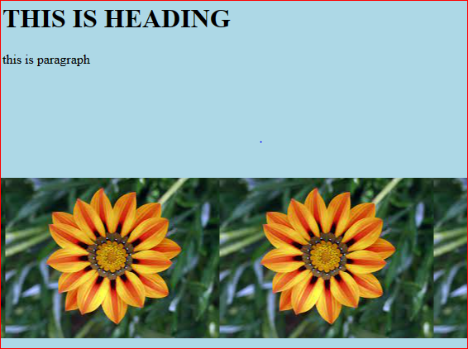

**2. CSS properties to change fonts and text styles.**

**a) CSS FONT FAMILY :**

**Code :**

<!DOCTYPE html>

<html>

<head>

<style>

.p1{

font-family:"Times News Roman","Times,serif";

}

.p2{

font-family:"Arial","Helvetica ","sans-serif ";

}

.p3{

font-family:"Lucida Console","Courier New","monospace";

}

</style>

</head>

<body>

<h1>CSS font-family</h1>

<p class="p1">This paragraph,shown in the Times News Roman font.</p>

<p class="p2">This paragraph,shown in the Arial font.</p>

<p class="p3">This paragraph,shown in the Lucida Console font.</p>

</body>

</html>

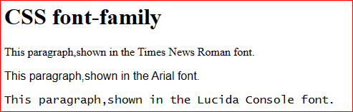

**b) CSS FONT SIZE :**

**CODE :**

<!DOCTYPE html>

<html>

<head>

<style>

h1 {

font-size: 40px;

}

h2 {

font-size: 30px;

}

p {

font-size: 14px;

}

</style>

</head>

<body>

<h1>This is heading 1</h1>

<h2>This is heading 2</h2>

<p>This is a paragraph.</p>

<p>This is another paragraph.</p>

</body>

</html>

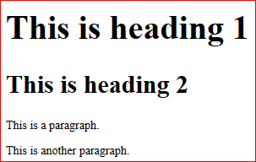

**c) CSS FONT STYLE :**

**CODE :**

<!DOCTYPE html>

<html>

<head>

<title>CSS FONT STYLE</title>

</head>

<style>

p.normal {

font-style: normal;

}

p.italic {

font-style: italic;

}

p.oblique {

font-style: oblique;

}

</style>

</head>

<body>

<h1>The font-style property</h1>

<p class="normal">This is a paragraph in normal style.</p>

<p class="italic">This is a paragraph in italic style.</p>

<p class="oblique">This is a paragraph in oblique style.</p>

</body>

</html>

OUTPUT :

